**Instructions**

# Write query and display the answers under each questions given below.

# use snipping tool to copy the query result and paste under each question.

1. Display a list of all data contained in the BOOKS table.

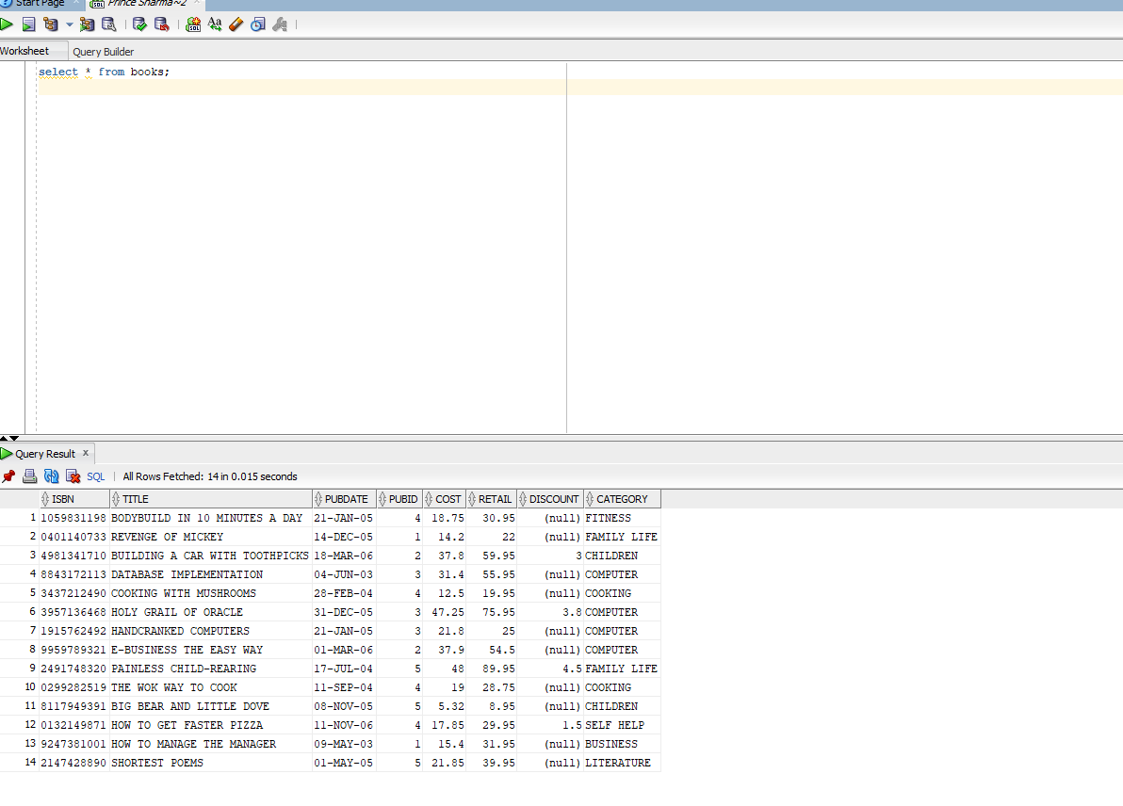

1. List the title and ISBN of all books using the BOOKS table.

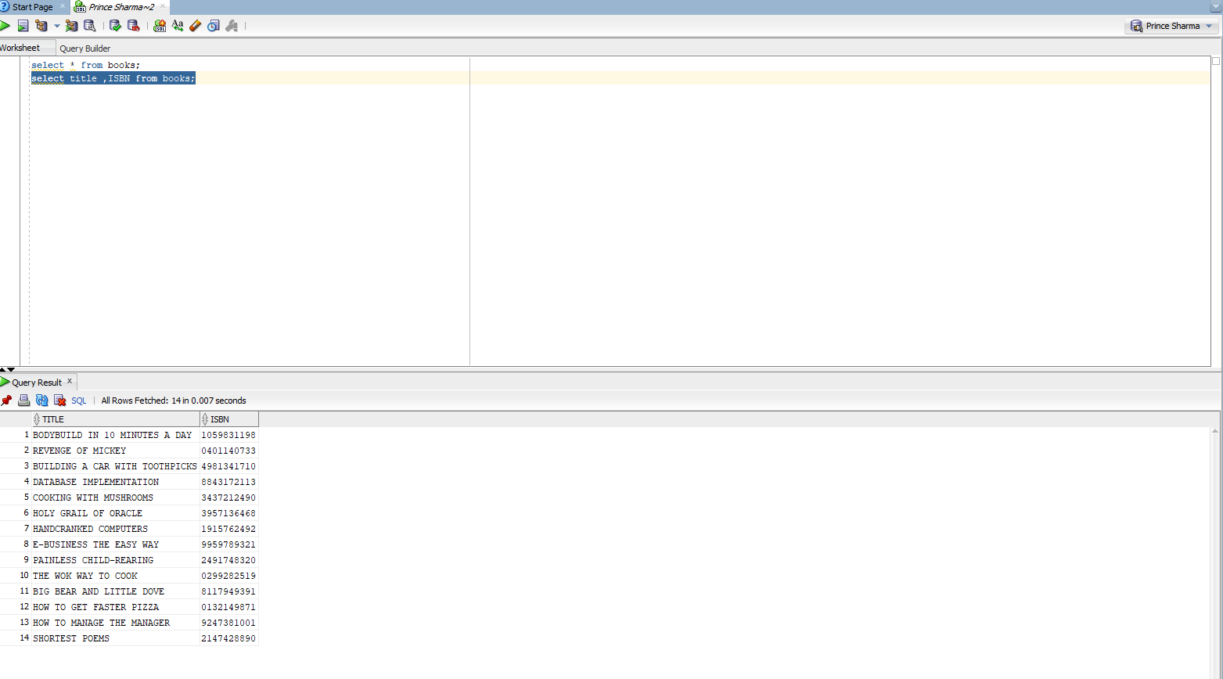

1. List the title and publication date for each book in the BOOKS table. Use the column heading “Publication Date” for the Pubdate field.

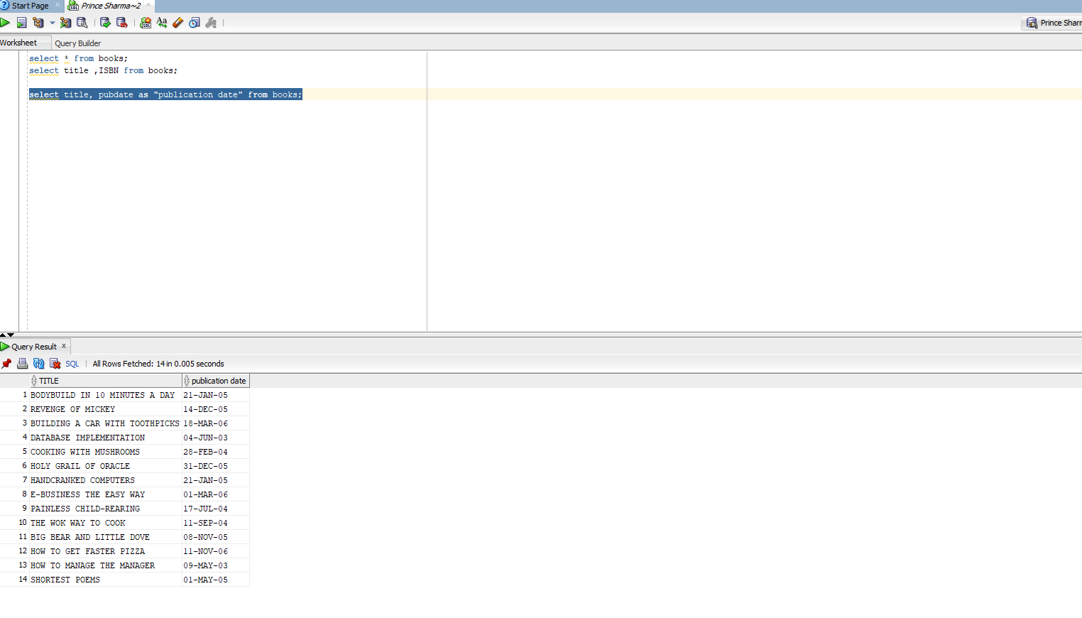

1. Determine which categories are represented in the current book inventory. List each category only once.

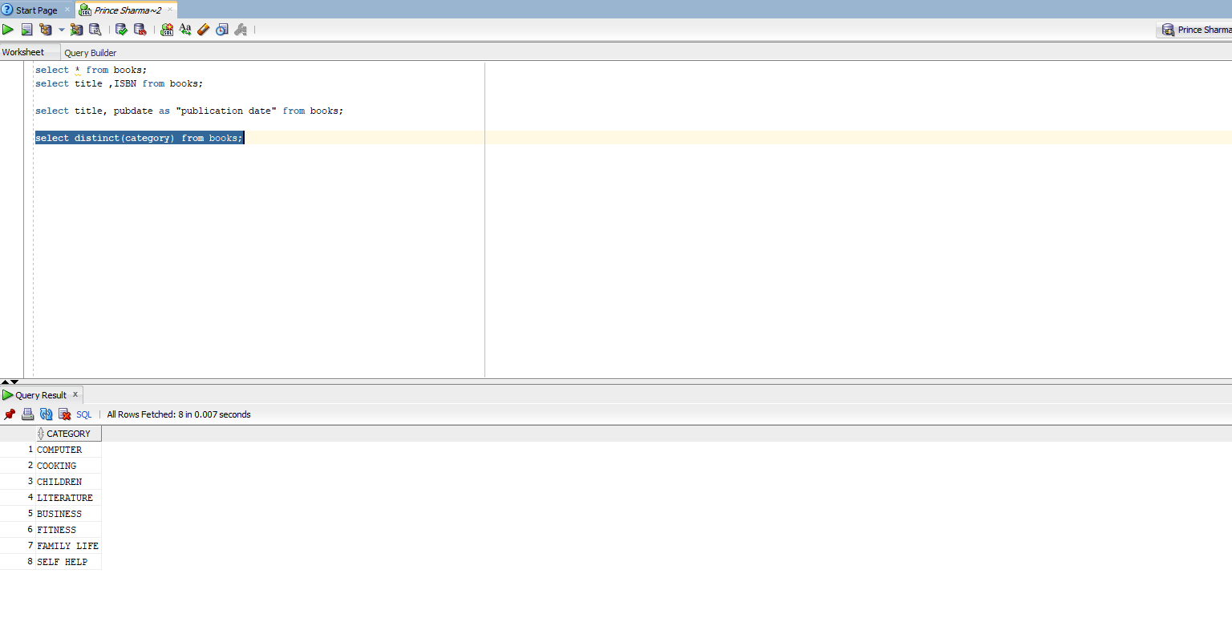

1. Write a query to display PUBDATE is after 21st January 2015

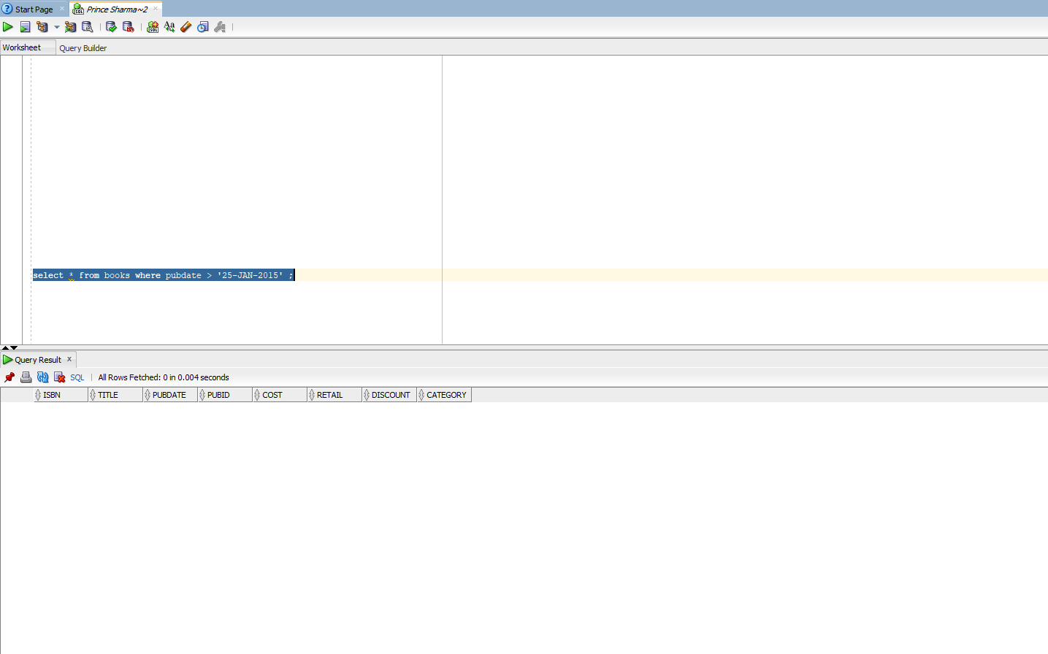

6. Rearrange the data in ascending order based on the cost of the book

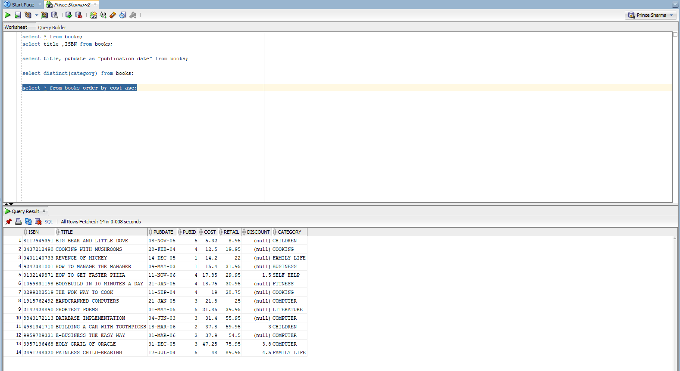

7.Display a list of all data expect the record which has ISBN no 1059831198

